AI / ML Internship — Week 3 Report
Supervised Learning: Titanic Survival Classification

What I Built
An end-to-end supervised machine learning pipeline that predicts Titanic passenger survival (binary classification) from the public Titanic dataset (891 rows, seaborn-data GitHub repository). The project covers data loading and validation, a documented data-quality check, a stratified train/test split performed before any preprocessing is fit, a leakage-free scikit-learn Pipeline (imputation, scaling, one-hot encoding), two trained and compared models, full evaluation, and a saved final model.

Approach
- Dropped 'alive' (a direct restatement of the target) and other redundant columns ('who', 'adult_male', 'class', 'embark_town', 'deck', 'alone'), keeping age, fare, sibsp, parch, pclass, sex, and embarked as features.
- Split data 80/20 (stratified, random_state=42) before fitting any preprocessing, to avoid leakage.
- Built a ColumnTransformer: median imputation + StandardScaler for numeric columns, most-frequent imputation + OneHotEncoder for categorical columns, wrapped inside a full sklearn Pipeline with each model.
- Trained a Logistic Regression baseline (5-fold cross-validated) and a Random Forest comparative model tuned with GridSearchCV. Both use class_weight='balanced' to address the dataset's mild 62/38 class imbalance.

Results
Model | Accuracy | Precision | Recall | F1
Logistic Regression (baseline) | 0.810 | 0.740 | 0.783 | 0.761
Random Forest (tuned, comparative) | 0.793 | 0.742 | 0.710 | 0.726

Cross-validation on the training set slightly favored the tuned Random Forest (F1 = 0.756) over the Logistic Regression baseline (F1 = 0.728). On the held-out test set the ranking flipped: Logistic Regression reached the higher F1 (0.761 vs. 0.726) and accuracy (81.0% vs. 79.3%). The Logistic Regression baseline was chosen as the final model because it generalized more consistently from cross-validation to the unseen test set.
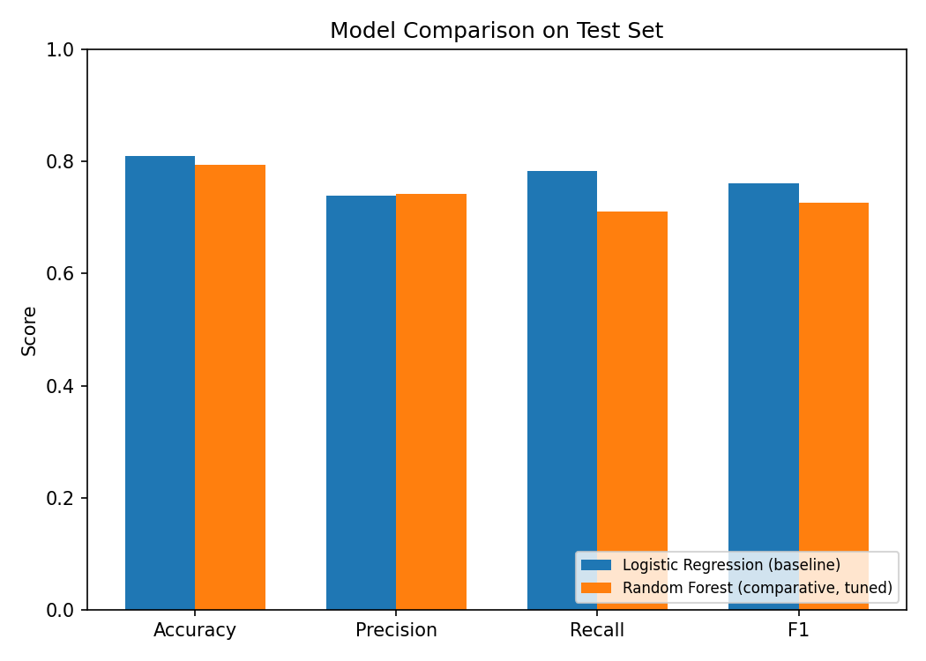

Challenges & How I Solved Them
- Data leakage risk: the 'alive' column is a text copy of the target, and several other columns ('who', 'class', 'embark_town') duplicate information in features I already kept. Solved by explicitly dropping them and documenting the reasoning in code comments and the README.
- Avoiding leakage during preprocessing: rather than fitting the imputer/scaler once on the whole dataset, I wrapped the ColumnTransformer inside the same sklearn Pipeline as each model, so it refits on the training fold only during cross-validation and GridSearchCV, not just the single train/test split.
- Model selection wasn't obvious: the tuned Random Forest had a better cross-validation score, but a worse test score, than the simpler baseline. Rather than defaulting to the more complex model, I compared both explicitly on the untouched test set and picked based on that result, and noted in the conclusion that the small dataset size makes this ranking sensitive to the random split.

Conclusion
The Logistic Regression baseline outperformed a tuned Random Forest on the held-out test set (F1 = 0.761 vs. 0.726), despite the Random Forest scoring slightly higher during cross-validation. On a dataset this small (712 training rows), a simpler, lower-variance model generalized more reliably than a more flexible tuned one. Feature importance from the Random Forest confirmed sex, fare, and passenger class as the strongest predictors, consistent with the historical Titanic evacuation pattern. Limitations include the small dataset size and a simple median-based age imputation. Next steps would include a class-aware imputation strategy for age, adding a gradient-boosting model for comparison, and testing result stability across multiple random splits rather than one. Full reasoning is in reports/conclusion.md; full metrics are in outputs/metrics/evaluation_report.txt.

Repository
asl-internship-aiml-week3-hashir — source, README, saved models, figures, and metrics reports are all included in the GitHub repository.

